

Ben-Gurion University of the Negev

Faculty of Engineering Science

School of Electrical and Computer Engineering

Dept. of Communication Systems Engineering

Fourth Year Engineering Project

PDR

Autonomous Driving using Swarms

**Project Number:** p-2023-003

**Students:** Noy Ella 312252257, Maayan Ben-Gal 311438733

**Supervisors:** Prof. Michael Segal

**Submitting Date:** 30/10/2022

**Table of Contents:**

Abstract 3

Abstract (English) 3

Abstract (Hebrew) 4

Research Proposal 5

The Essence of the Project 5

Technologies and Methodologies that Will be Used in the Project 5

Work Plan 6

Application for our Project 6

System Performance Spec 6

Project General Scheme 6

Design Approach 7

Different Approaches for the Problem Presented 7

Our Approach 7

Bibliography 9

Appendix: PDR Evaluation 10

1. **Abstract**
   1. **Abstract (English):**

**Autonomous Driving using Swarms**

Students Names: Ben-Gal Maayan, Ella Noy

bengalm[@post.bgu.ac.il](mailto:axalrod@post.bgu.ac.il)

Cars are the future.

Keywords – Autonomic cars,

* 1. **Abstract (Hebrew):**

**נהיגה אוטונומית בעזרת להקות**

שמות הסטודנטים: בן-גל מעיין, אלה נוי

bengalm[@post.bgu.ac.il](mailto:axalrod@post.bgu.ac.il)

עתיד התחבורה תלוי בפיתוח רכבים אוטונומיים הנדרשים לתפקד בזמן אמת ולקבל החלטות בהתאם לתנאי התנועה והשטח, כאשר יצירת קשר עם גורם חיצוני כגון חדר בקרה עלול לקחת זמן יקר ולגרום לתאונות במקרה של נפילת תקשורת.

מטרת הפרויקט לפתח אלגוריתם המייצר להקות רכבים הנעים בכביש בעזרת תקשורת עמית לעמית (P2P) באופן מבוזר. כל להקה היא קבוצת רכבים הנעה יחד כרכב אחד, על פי יעד הנסיעה בהתאם לרכבים הממוקמים על הכביש בזמן אמת.

על האלגוריתם לארגן את הרכבים כך שכמות השלבים עד להתייצבות הלהקות בכביש תהיה מינימלית.

הרעיון של תקשורת ללא שרת חיצוני הוא חדשני בהקשר של רכבים אוטונומיים. מעבר לרעיון התקשורת ללא גורם אנושי רעיון הלהקות יכול לשפר משמעותית את קבלת ההחלטות של רכב.

שיטת העבודה תכלול מספר קבוע של רכבים על כביש בעל למעלה מנתיב אחד, כאשר לכל רכב יש צבע על פי יעדו הסופי. לכל מכונית ישנה יכולת לתקשר עם רכבים עד 100 מטר, על מנת לזהות את חבריו העתידיים ללהקה. לאחר התמודדות עם מצב זה נוסיף מקרי קצה במטרה לשפר את האלגוריתם ולהתאימו למציאות. בסיום הפרויקט הצפי הוא לפתח אלגוריתם ראשוני יחיד שיותקן על כל מערכות הרכבים האוטונומיים וייבצע את ארגון הרכבים ללהקות בזמן מינימלי.

מילות מפתח: רכבים אוטונומיים, אלגוריתמים מבוזרים, P2P, להקות, מיון גרף על פי צבע, זמן אמת, SUMO (תוכנת סימולציית רכבים).

1. **Research Proposal**

Autonomous Driving using Swarms

* 1. **The Essence of the Project:**

The goal of the project is to create an algorithm that maps autonomic cars to swarms using peer-to-peer communication in real-time with minimal steps until the stabilization of the swarms. The idea is to sort the cars by their destination by marking every car with color and creating a swarm from all the cars with the same color on the road, this way every swarm can move and be referred to as a single car. The swarm have inner between the cars and outer communication via gateway car which reduces the number of messages. The cars as a swarm need to decide the role of each car in the swarm (leader of the swarm, gateway car and etc) so the decisions of each car can be more efficient.

* 1. **Technologies and Methodologies that Will be used in the Project:**
     + Communication protocols – The cars use peer-to-peer communication when there is a difference between communication inside the swarm and outside the swarm. The car can communicate by broadcasting messages to all the cars around her, and unicast messages. Broadcast messages are required to find close cars with the same color, and the unicast messages are requiring communicating with a specific car to join powers and become a swarm or communicate directly to the swarm leader or use algorithms to decide the leader along with the swarm.
     + Physical conditions – The algorithm we want to create must depend on a few physical conditions like the way the road is, the number of lanes in the road, the different cars or traffic around each car, the communication ability of the cars, and even the speed limit. All these physical conditions are important and need to be considered in the protocols and the algorithm. For example, in order for a swarm to move at a constant speed it needs to know the speed limit, or the cars can only send a message for a specific range distance. The initial physical conditions are an infinite road with 2 lanes and no speed limit, the cars can send a message up to 100 meters radius.
     + Simulation of Urban Mobility (SUMO) – SUMO is an open-source, microscopic, multi-modal traffic simulation. SUMO can simulate large traffic and network features, it can be used in Python. This package is the way the algorithm simulation tool that will be use to simulate different states and edge cases. [2]
     + Driving Protocols – The cars are autonomic, that means they need to know how to drive as a human driver, the cars must know simple driving protocols – such as speeding up, slowing down, pass other cars by speeding in another lane, stop at red light and even hit the brakes when needed. The algorithm assumes the cars has this knowledge and build at first easier and more ideal conditions in order to deal with edge cases and different situations as required.
  2. **Work Plan:**
     + Create a basic algorithm that handles with only two swarms on 2 lanes infinite road.
     + Simulate the algorithm and checking simple edge cases and check the algorithm performance.
     + Develop the algorithm for more than two swarms and more than two lanes, check if the way of decision making is more efficient and if the traffic can be stabilized into swarms with minimal steps.
     + Simulate and check the efficiency in cases when a new car enters the road or leave the road along with other simple edge cases.
     + Formulate the protocol that should be coded on every single car.
     + Try to formulate a protocol that can be used on an autonomic cars and semi-autonomic cars as well, define protocols dealing with complicated human-dependent edge cases, and create a simulation with randomly generated traffic to test it.
  3. **Applications for the Project:**

The algorithm can change the way autonomic cars are perceived, get a better way of monitoring the autonomic traffic and lower the risks around real-time decisions of autonomic individual cars. The algorithm allows the cars to lower the dependence on navigating systems and lower the risks around other cars' decisions – when the cars drive as a swarm there is a lower risk of a car interrupting the traffic unexpectedly and making the other cars react and decide in real-time with higher risk for accidents.

* 1. **System Performance Spec:**

We expect our project implementations to accelerate current datacenter networks performance. The caching mechanism should be easily deployable in all current programmable switches running in an SDN network. Our input is packets corresponding to several flows, and we expect to see a reduction in the network's packet processing time.

The equipment needed for this research is a PC equipped with emulation software, and enough memory to emulate a significant number of switches and hosts.

* 1. **General Scheme:**
     + The current state of the system built last year:

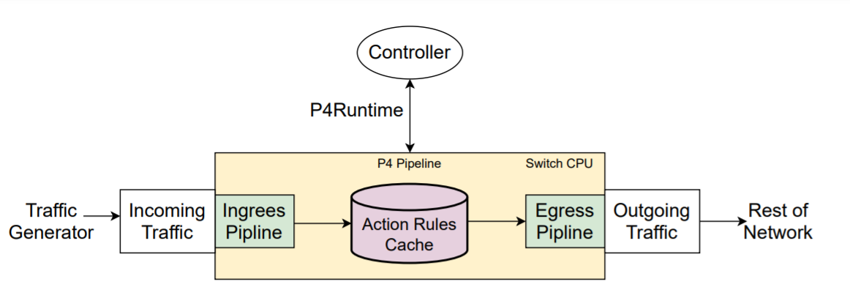

Figure 1: General flow of the system that was built last year.

* + - The desired topology to actualize:

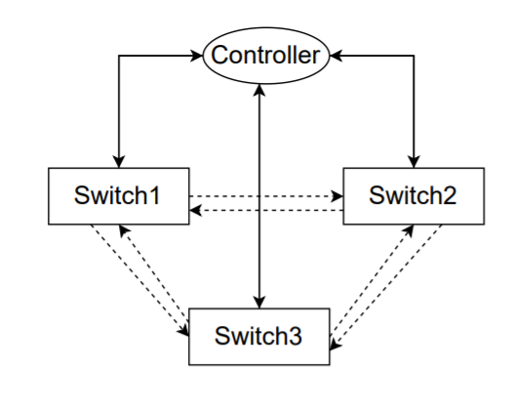

Figure 2: The desired topology of the network.

As described in Fig. 1, the existing model consists only of a single switch with a single controller. In our project we plan to create the topology described in Fig. 2. This topology will be composed in a distributed way and includes three switches and a single controller. Furthermore, all components will relate to at least one port between one another. In a further stage, we plan to try and create more complex topologies, in case the topology described in Fig. 2 will yield the expected results.

1. **Design Approach**
   1. **Different Approaches for the Problem Presented**

* One approach is developing an algorithm that create the swarms according to physical geographical proximity of the vehicles in real time**.** That is, the cars on the road will communicate and connect to a collective according to their position on the road at a minimum distance. In prof. Michael Segal article [1] a D-Cut algorithm is presented that generates clusters of vehicles according to their position on the road and chooses a temporary leader for the swarm each time. The advantage of this approach is that the swarm creation and stabilization time is fast. Another advantage is that there is a limit on the number of vehicles in each cluster, which gives a simple intra-swarm communication protocol. A disadvantage of this approach is the instability of the swarm in a situation where a vehicle leaves the group when it reaches its destination. Since the vehicles in the swarm do not necessarily reach the same destination, the group will not remain intact throughout the route.
  1. **Our Approach:**

This project is an initial project that will continue for more years in the future with the aim of developing an initial algorithm for creating a swarm of vehicles.

* **Project Limitations**
  + Mininet-based networks environment cannot (currently) exceed the CPU or bandwidth available on a single server [7].
  + Mininet environment cannot (currently) run non-Linux-compatible OpenFlow switches or applications [7].
  + There is not currently a way to examine our system in a real-life datacenter network since we do not have access to one.
* **Project Assumptions**
  + Our main assumption is that the system is described in Fig. 1. is working correctly, and the simulation environment is working with a single switch connected to a single controller, given traffic in the network.
  + We assume the availability of an SDN controller.
  + We assume BMv2 P4 implementation in Mininet is stable.

1. **Bibliography**

|  |  |
| --- | --- |
| [1] | Yair Allouche and Michael Segal. “A cluster-based beaconing approach in vanets: Near optimal topology via proximity information”. English. In: Mo- bile Networks and Applications 18.6 (Dec. 2013) |
| [2] | SUMO Overview. https://www.eclipse.org/sumo/ |
| [3] |  |
| [4] |  |
| [5] |  |
| [6] |  |
| [7] |  |

1. **Appendix: PDR Evaluation**

**הערכה לשיחת סקר תכנון ראשוני (PDR)**

אם יש צורך, לכל סטודנט/ית בנפרד

מספר הפרויקט: p-2023-003

שם הפרויקט: נהיגה אוטונומית בעזרת להקות.

שם המנחה מהמחלקה: פרופסור מיכאל סגל.

שם הסטודנטית: נוי אלה ת.ז.: 312252257

שם הסטודנטית: מעיין בן גל ת.ז.: 311438733

|  |  |  |  |
| --- | --- | --- | --- |
| % | מהות | ציון | הערות |
| 10 | שיחה + דו"ח - הבנת הנושא ומהות העשייה, הבנת הצורך, סביבת היישום, הגדרת מדדים, מקורות ועבודות דומות.  הצגת התקצירים, מפרט טכני/הצעת מחקר והצעת תכנון מפורטים. |  |  |
|  |  |  |  |
|  | ציון סופי |  |  |

הערות: